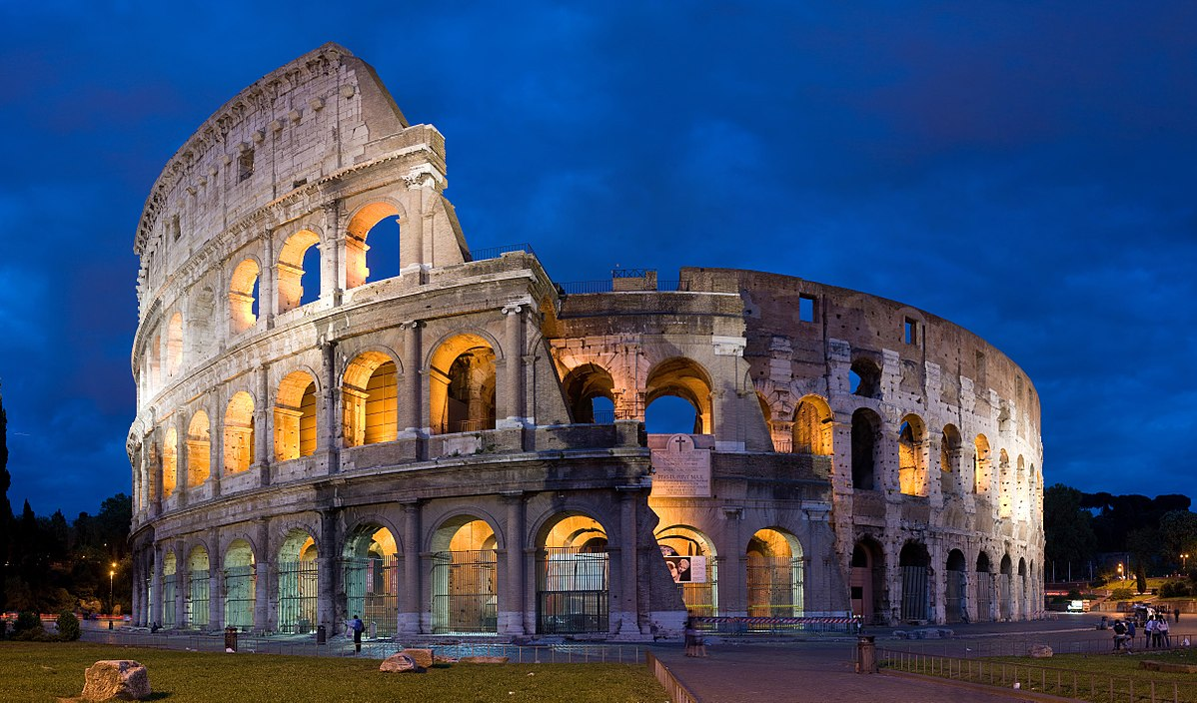
WIN

A LONG WEEKEND AWAY IN ROME FOR TWO.

