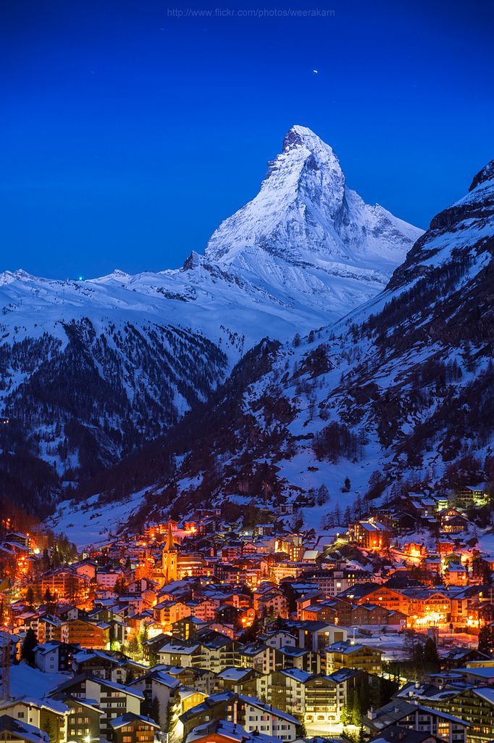



**WIN A ONE WEEK TRIP**

**FOR TWO SKIING IN THE SWISS ALPS** 